**NAME-Jagrit Taneja**

**REG NO-20BRS1002**

**COURSE- Simulation and Modelling**

**COURSE CODE:CSE3102**

**LAB-6**

**STEPS:**

1. **Launch roscore**

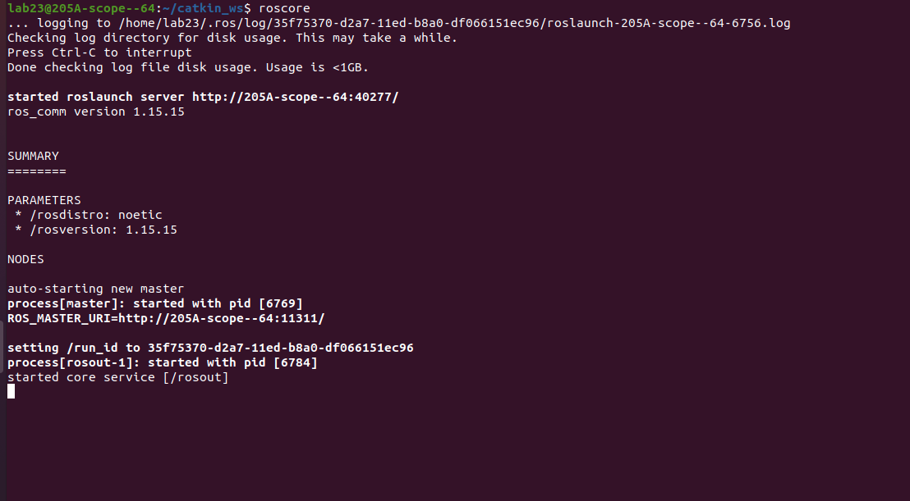

1. Run catkin_make

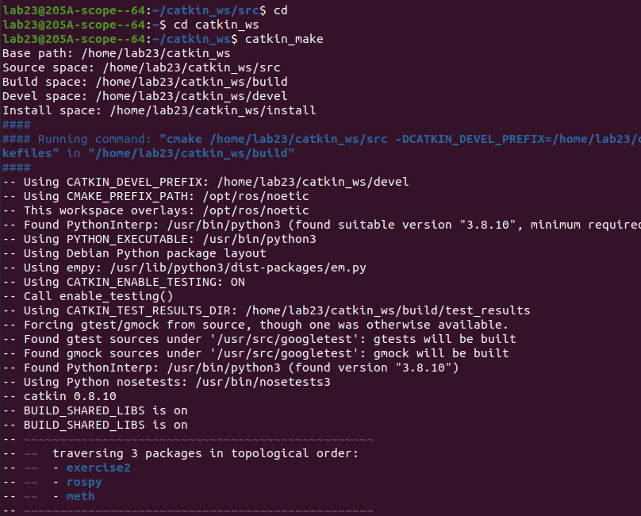

1. Lauch bot.launch

1. Run cmd_bot

1. Final Output

